**FAKE NEWS DETECTION USING NLP**

**Project :** Fake news detection

**Introduction:**

Detecting fake news using Natural Language Processing (NLP) is a critical and evolving area of research and technology. In a world where misinformation can spread rapidly, NLP offers a powerful tool to differentiate between genuine and deceptive content. This methodology leverages linguistic patterns, text analysis, and machine learning algorithms to assess the credibility of information sources, identify misinformation, and ultimately help safeguard the integrity of information in the digital age. In this discussion, we'll explore the key components and techniques involved in the fascinating field of fake news detection using NLP.

**1.Data Source :**

- Gather and inspect the Kaggle dataset containing news articles and their labels (genuine or fake).

- Explore and analyze the dataset to understand its characteristics, including data distribution and potential challenges.

**2.Data Preprocessing:**

- Tokenize the text data, removing punctuation, special characters, and irrelevant information.

- Perform stemming or lemmatization to standardize words.

- Handle missing data and outliers appropriately.

**3.Feature Extraction:**

- Utilize techniques such as TF-IDF (Term Frequency-Inverse Document Frequency) or word embeddings (e.g., Word2Vec, GloVe) to represent text data numerically.

- Create a feature matrix for both titles and text content.

**4.Model Selection:**

- Experiment with various machine learning models for classification, including but not limited to:

- Logistic Regression

- Naive Bayes

- Random Forest

- Support Vector Machine (SVM)

- Deep Learning Models (e.g., LSTM, BERT)

**5.Model Training:**

- Train these models on the preprocessed data and evaluate their performance using appropriate metrics (e.g., accuracy, precision, recall, F1-score).

**6.Evaluation:**

- Assess the model's performance on a separate test dataset to gauge its effectiveness in distinguishing between genuine and fake news.

- Employ evaluation metrics to measure the model's accuracy, reliability, and robustness.

**1.Data Collection and Preprocessing:**

* + Gather a diverse dataset of news articles and labels (fake or real).

  - Perform data cleaning, tokenization, and text preprocessing.

* + Split the dataset into training, validation, and test sets.

**2.LSTM Model:**

* + Implement a Long Short-Term Memory (LSTM) neural network for sequential data processing.
  + Design the LSTM architecture with embedding layers and recurrent layers.
  + Train the LSTM model on the preprocessed training data.
  + Fine-tune hyperparameters to optimize performance.

3. **BERT Model:**

- Utilize the pre-trained BERT model for natural language understanding.

   Fine-tune BERT on the fake news detection task using the training data.

  . - Implement techniques such as tokenization, attention masks, and positional embeddings.

* + Experiment with different BERT variants (e.g., BERT, RoBERTa, DistilBERT) for performance comparison.

 4.**Model Evaluation:**

  - Evaluate the LSTM and BERT models on the validation dataset using metrics such as accuracy, precision, recall, and F1-score.

* + Perform cross-validation to ensure robustness.
  + Visualize and analyze the models’ performance using confusion matrices and ROC curves.

 5. **Ensembling**:

* + Combine the LSTM and BERT models using ensemble techniques (e.g., stacking, voting) to leverage their strengths and improve overall accuracy.

 6.**Fine-Tuning and Optimization:**

* + Experiment with various optimization algorithms (e.g., Adam, RMSprop) and learning rates to enhance model convergence.
  + Apply techniques like dropout and regularization to prevent overfitting.

 7. **Deployment**:

* + Develop a user-friendly web or mobile application to allow users to input news articles for fake news detection.
  + Deploy the models to a cloud-based server for real-time inference.
  + Implement an intuitive user interface for easy interaction.

 8. **Performance Monitoring and Updates:**

* + Continuously monitor the models’ performance in a production environment.
  + Collect user feedback to improve the system’s accuracy and user experience.
  + Periodically retrain the models with new data to adapt to evolving fake news trends.

 9. **Documentation and Reporting:**

* + Create comprehensive documentation for the project, including data sources, preprocessing steps, model architectures, and deployment instructions.
  + Prepare a report summarizing the project’s methodology, findings, and recommendations for future enhancements.

 10. **Future Work:**

- Explore advanced techniques like attention mechanisms, adversarial training, and self-attention for further model improvement.

- Investigate the incorporation of multi-modal data (text, images, videos) for a more comprehensive fake news detection system.

**Necessary steps to follow:**

1.Import necessary libraries:

**Program:**

Import pandas as pd

From sklearn.model_selection import train_test_split

From sklearn.feature_extraction.text import TfidfVectorizer

From sklearn.preprocessing import LabelEncoder

2.Load the dataset:

You can use a dataset in a CSV format. For example:

**Program:**

Dataset = pd.read_csv(‘fake_news_dataset.csv’)

3.Explore the dataset:

* Check the structure of the dataset, including columns and labels.

4.Preprocess the text data:

* Handle missing values if any.
* Remove any irrelevant columns.
* Clean and preprocess the text data by removing punctuation, stopwords, and performing tokenization. You can use libraries like NLTK or spaCy for this.

5.Split the dataset into training and testing sets:

**Program:**

X = dataset[‘text’] # Text data

Y = dataset[‘label’] # Labels (e.g., ‘real’ or ‘fake’)

X_train, X_test, y_train, y_test = train_test_split(X, y, test_size=0.2, random_state=42)

6.Convert text data to numerical features:

Use techniques like TF-IDF (Term Frequency-Inverse Document Frequency) vectorization to convert the text data into numerical format:

**Program:**

Tfidf_vectorizer = TfidfVectorizer(max_features=5000)

X_train_tfidf = tfidf_vectorizer.fit_transform(X_train)

X_test_tfidf = tfidf_vectorizer.transform(X_test)

7.Encode labels:

Convert the categorical labels (e.g., ‘real’ and ‘fake’) into numerical values:

**Program:**

Label_encoder = LabelEncoder()

Y_train_encoded = label_encoder.fit_transform(y_train)

Y_test_encoded = label_encoder.transform(y_test)

Now, you have a preprocessed dataset with text data represented as numerical features. You can use this dataset to train a machine learning model, such as a classifier, for fake news detection using NLP techniques. Make sure to choose an appropriate NLP model (e.g., Naïve Bayes, Logistic Regression, or more advanced models like BERT) and evaluate its performance on the test set to assess its accuracy in detecting fake news.

**Code:**

Now, we will try to implement machine learning methods for the detection of fake news. Here we will have two datasets: “Fake.csv” and “True.csv”.

One contains fake news, and the other contains true news.

**Importing Libraries:**

Import pandas as pd

Import numpy as np

Import seaborn as sns

Import matplotlib.pyplot as plt

From sklearn.model_selection import train_test_split

From sklearn.metrics import accuracy_score

From sklearn.metrics import classification_report

Import re

Import string

**Importing Dataset:**

dataframe_fake = pd.read_csv(“Fake.csv”)

dataframe_true = pd.read_csv(“True.csv”)

dataframe_fake.head()

**Output:**

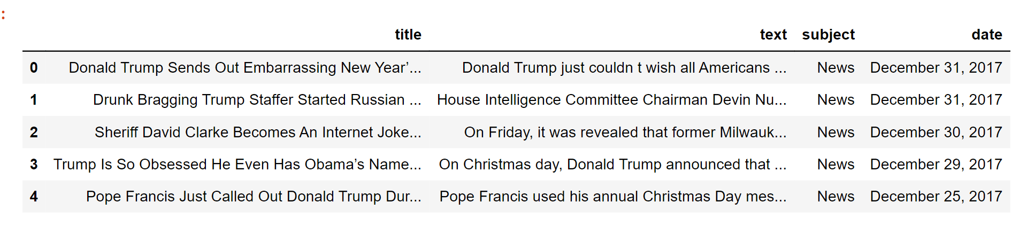

dataframe_true.head()

**Output:**

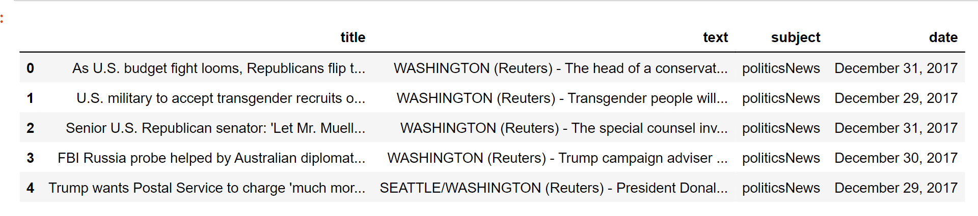

Now we will insert a column in both of the datasets named “class”, which will be the target feature. In a fake dataframe, we will give a value of 1 to the class and on the other hand, with true, we will allocate 0.

dataframe_true[“class”] = 0

dataframe_true[“class”] = 1

# Now, we will look at the shape of both the dataset

dataframe_fake.shape, dataframe_true.shape

**Output:**

( (23481,5 ) , (21417,5) )

dataframe_fake dataset contains 23481 rows and 5 columns.

dataframe_true dataset contains 21417 rows and 5 columns.

Let’s have some manual testing

# We will remove the last 10 rows for manual testing

dataframe_fakedataframe_fake_manual_testing = dataframe_fake.tail(10)

For i in range(23480,23470,-1):

dataframe_fake.drop([i], axis = 0, inplace = True)

dataframe_truedataframe_true_manual_testing = dataframe_true.tail(10)

for i in range(21416,21406,-1):

dataframe_true.drop([i], axis = 0, inplace = True)

# Let’s have a look at the change in the shape of both the dataset

dataframe_fake.shape, dataframe_true.shape

**Output:**

( (23471,5) , (21407,5) )

If you look here, there is a decrease in the number of rows. It is because we took 10 rows from each dataset for manual testing.

#Inserting the class column in both of the manual testing datasets.

dataframe_fake_manual_testing[“class”] = 0

dataframe_true_manual_testing[“class”] = 1

dataframe_fake_manual_testing.head(10)

**Output:**

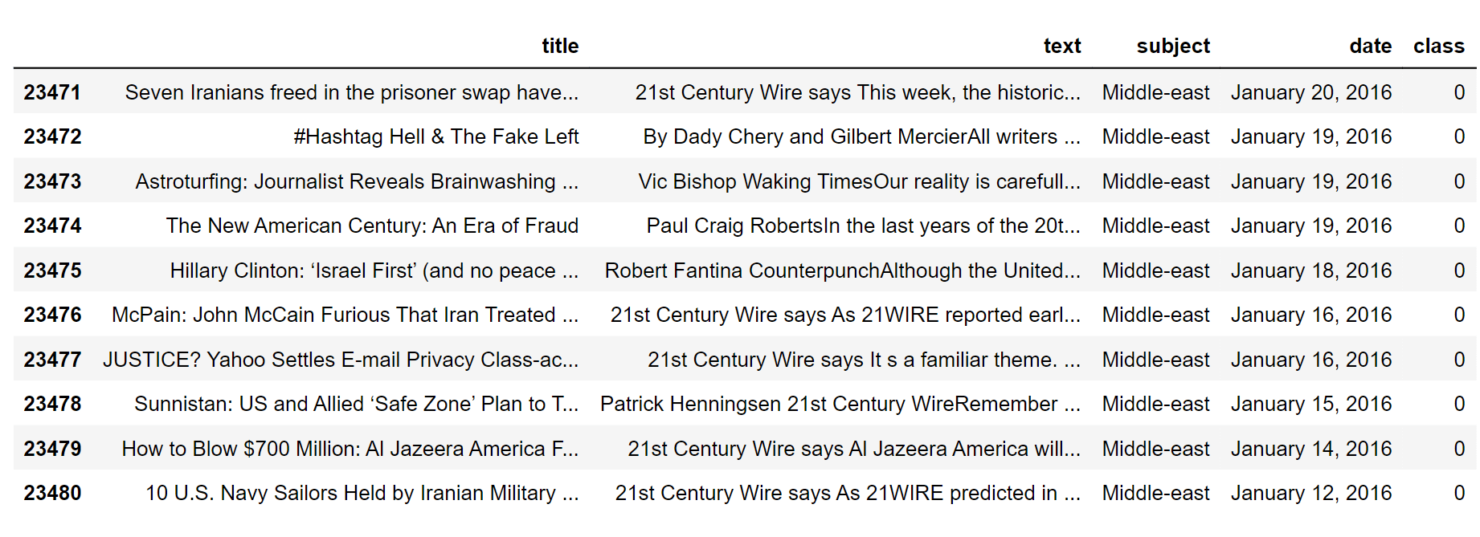

dataframe_true_manual_testing.head(10)

**Output:**

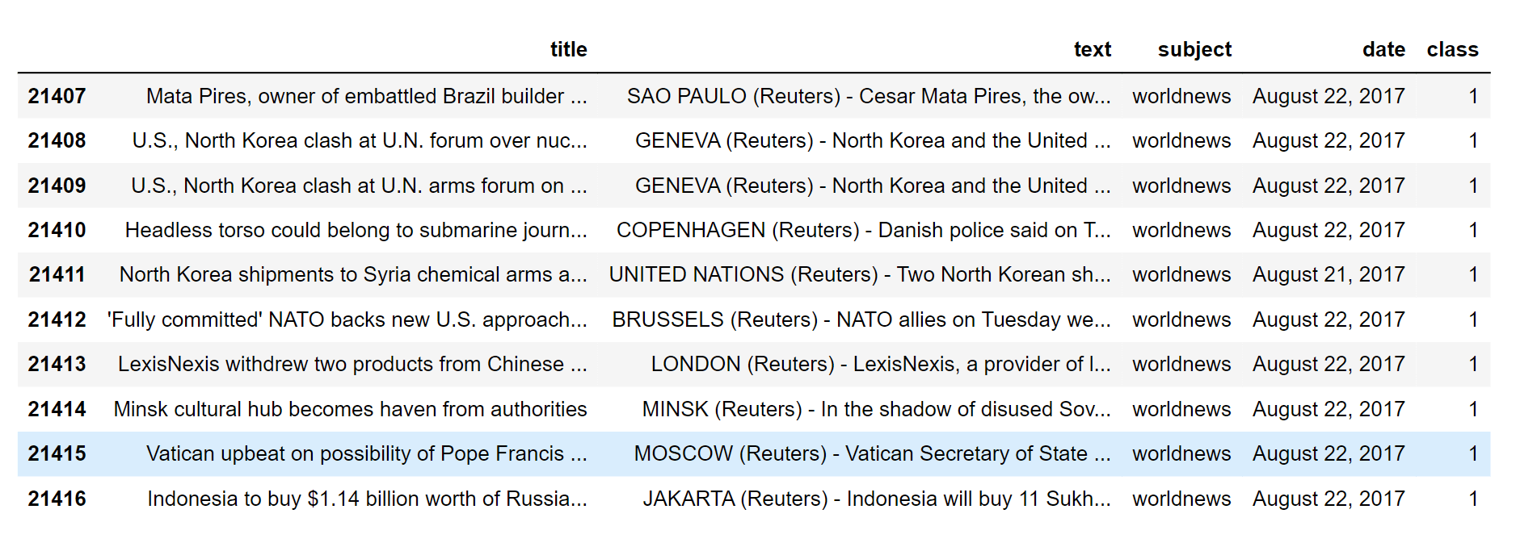

**Merging True and Fake Dataframes:**

Here, we will merge ‘dataframe_fake’ and ‘dataframe_true’ to form a new dataset so that we perform the machine learning operations on it.

dataframe_merge = pd.concat([dataframe_fake, dataframe_true], axis =0 )

dataframe_merge.head(10)

**Output:**

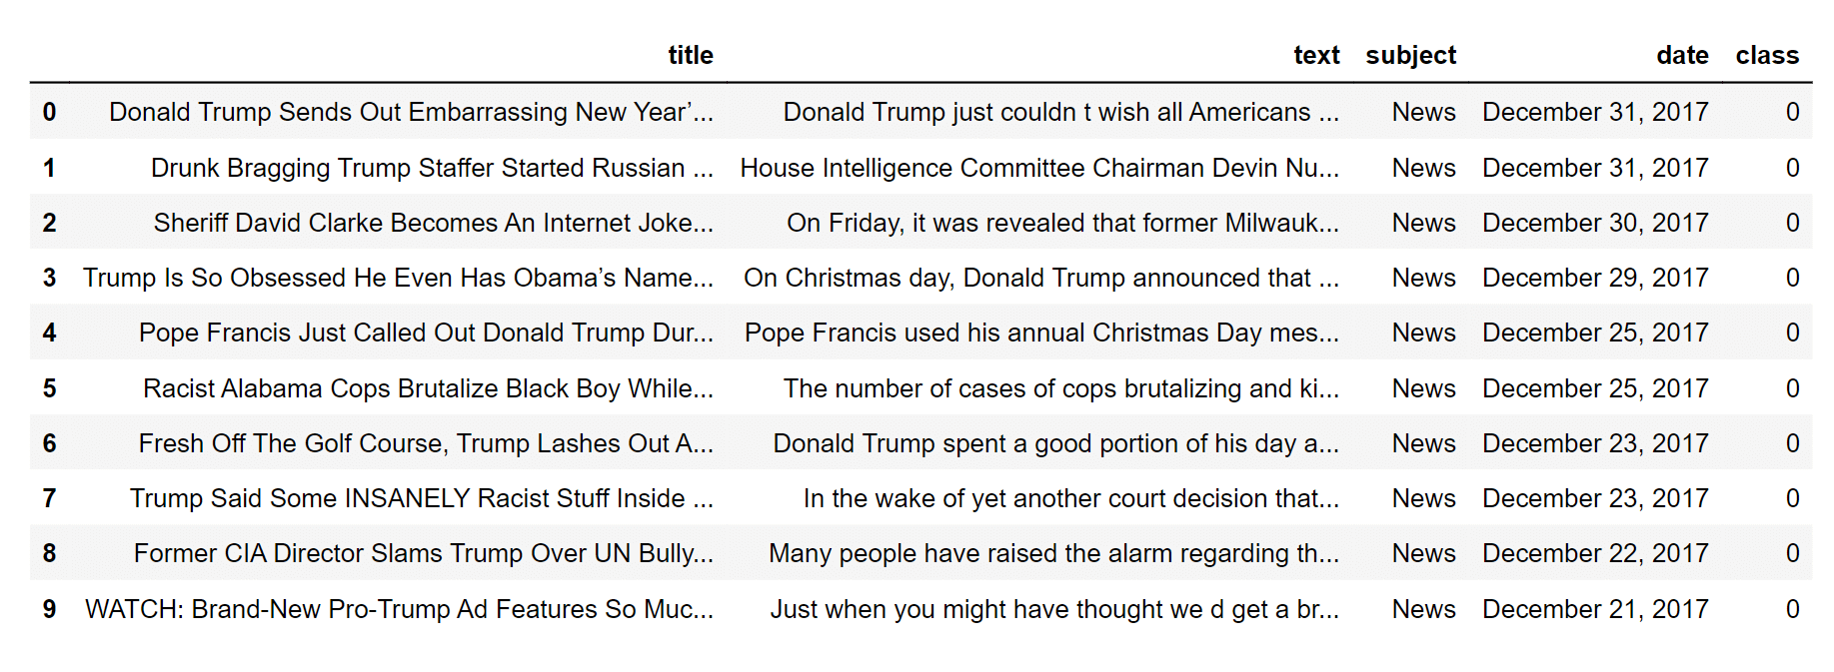

When we have concat the datasets, the rows don’t have randomness.

# We will remove the columns that are required for us

dataframe = dataframe_merge.drop([“title”, “subject”,”date”], axis = 1)

# Let’s check if there are any null values in the dataset

dataframe.isnull().sum()

**Output:**

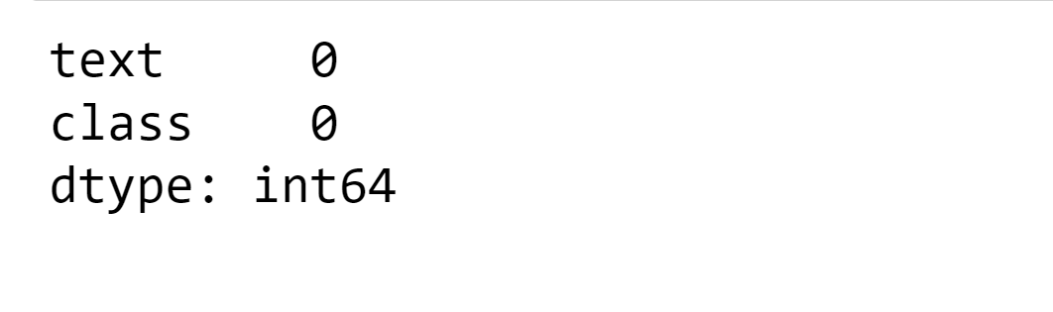

Luckily, we don’t have any missing values in our dataset.

As we have only concat the two datasets so it will be true and fake datasets are arranged just after one another. So we need to create randomness in the dataset. We can shuffle the rows of the dataset.

# Here is the random shuffling of the rows in dataset

dataframedataframe= dataframe.sample(frac = 1)

dataframe.head()

**Output:**

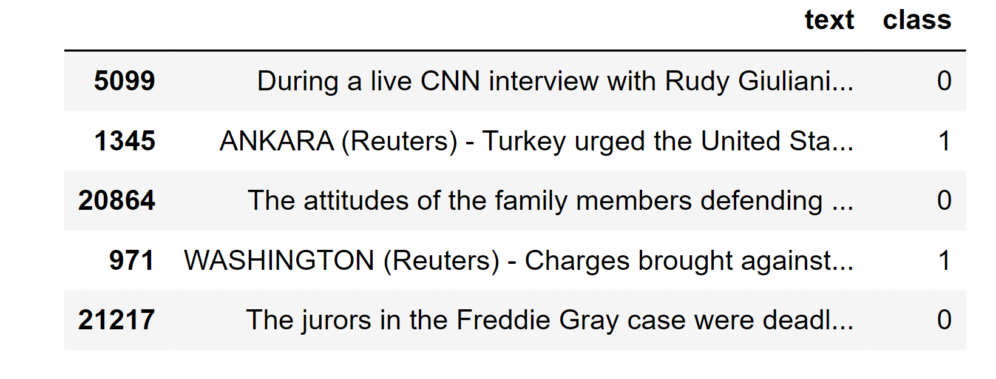

**Feature engineering :**

Feature engineering is a critical step in building a fake news detection project. It involves selecting and transforming relevant features from your data that can help machine learning models distinguish between real and fake news. Here are some common feature engineering techniques and considerations for a fake news detection project:

1.Text-based Features:

* Word Frequency: Create features based on the frequency of words or n-grams (word combinations) in the text. This can help in identifying specific language patterns used in fake news.
* TF-IDF (Term Frequency-Inverse Document Frequency): TF-IDF can be used to weigh the importance of words in the text, giving more weight to rare terms that might be indicative of fake news.

1. Sentiment Analysis:

Analyze the sentiment of the text. Fake news might have distinct emotional tones or excessive use of emotional language. You can use tools like VADER or sentiment analysis libraries to extract sentiment scores.

3.Source and Metadata:

Extract information about the source of the news, such as the website or publication date. Fake news sources often have a history of spreading misinformation.

Analyze metadata like the number of shares, comments, and likes on social media, as these can be indicators of the content’s credibility.

1. Author Features:

Analyze author profiles, credibility, and writing style. Fake news might be associated with pseudonyms or inexperienced authors.

1. Structural Features:

Investigate the structure of the text, such as the length of the article, the number of paragraphs, and the use of bullet points or headlines. Fake news may have a different structure from legitimate news articles.

1. Network Analysis:

If you have access to a network of news sources, you can analyze the relationships between different sources and detect patterns of information sharing.

1. Linguistic and Stylistic Features:

Look at linguistic cues like grammar, readability, and coherence. Fake news articles may have more errors, inconsistencies, or sensationalist language.

1. Fact-checking Information:

Use external fact-checking data to cross-reference claims made in the news articles. Incorporating fact-checking information as features can be valuable.

1. User-generated Content:

Analyze user comments, reactions, and discussions related to the news articles. The sentiment and language used by readers can also provide insights.

1. Multimedia Analysis:

For news articles containing images or videos, you can extract features from these media, such as image content analysis or video frame analysis.

Feature engineering for fake news detection typically involves preparing the data by extracting, transforming, and creating relevant features for your machine learning model. Here’s a Python code example using the `pandas` library for data manipulation. Assume you have a dataset with columns for “title” and “text” as your text data, and a “label” column indicating whether the news is fake (1) or real (0).

Import pandas as pd

From sklearn.feature_extraction.text import TfidfVectorizer

From sklearn.model_selection import train_test_split

# Load your dataset

Data = pd.read_csv(‘fake_news_dataset.csv’)

# Text-Based Features

Tfidf_vectorizer = TfidfVectorizer(max_features=5000, stop_words=’english’)

Tfidf_matrix = tfidf_vectorizer.fit_transform(data[‘title’] + ‘ ‘ + data[‘text’])

Tfidf_features = pd.DataFrame(tfidf_matrix.toarray(), columns=tfidf_vectorizer.get_feature_names_out())

# Sentiment Analysis

From vaderSentiment.vaderSentiment import SentimentIntensityAnalyzer

Analyzer = SentimentIntensityAnalyzer()

Data[‘sentiment’] = data[‘text’].apply(lambda x: analyzer.polarity_scores(x))

Data[‘compound_sentiment’] = data[‘sentiment’].apply(lambda x: x[‘compound’])

# Source and Metadata Features

Data[‘source_reliability’] = data[‘source’].map(source_reliability_dict)

Data[‘publication_date’] = pd.to_datetime(data[‘publication_date’])

Data[‘days_since_published’] = (pd.to_datetime(‘2023-10-26’) – data[‘publication_date’]).dt.days

# Structural Features

Data[‘text_length’] = data[‘text’].apply(len)

Data[‘num_paragraphs’] = data[‘text’].apply(lambda x: x.count(‘\n’))

# Combine all features

Features = pd.concat([tfidf_features, data[[‘compound_sentiment’, ‘source_reliability’, ‘days_since_published’, ‘text_length’, ‘num_paragraphs’]]], axis=1)

# Target variable

Target = data[‘label’]

# Split the data into training and testing sets

X_train, X_test, y_train, y_test = train_test_split(features, target, test_size=0.2, random_state=42)

This code demonstrates the feature engineering process by extracting TF-IDF features, sentiment analysis, source and metadata information, structural features, and combining them into a feature matrix. Ensure that you replace `’fake_news_dataset.csv’` with the path to your dataset and adjust the feature extraction methods to your specific needs.

After this feature engineering step, you can proceed with model selection and training using libraries like scikit-learn or TensorFlow for machine learning tasks.

**Model Training:**

There are a number of machine learning algorithms that can be used for fake news detection such as Logistics regression, Decision tree classifier, Gradient boost classifier, Random forest classifier.

Creating a mathematical model of a system or dataset involves utilizing a variety of techniques and algorithms. When given new data, the model can predict or take action based on patterns and correlations it has learned from the input data.

Here we will use different machine learning algorithms to train them on the dataset and later use them for the prediction of fake news.

**1.Logistic Regression**

**Program:**

From sklearn.linear_model import LogisticRegression

LR = LogisticRegression()

LR.fit(xv_train,y_train)

**Output:**

Logistics regression()

Pred_lr=LR.predict(xv_test)

LR.score(xv_test, y_test)

**Output:**

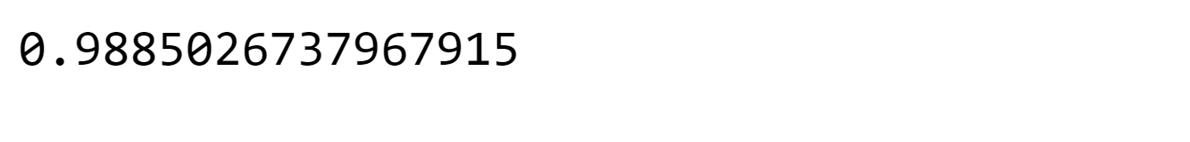

Print(classification_report(y_test, pred_lr))

**Output:**

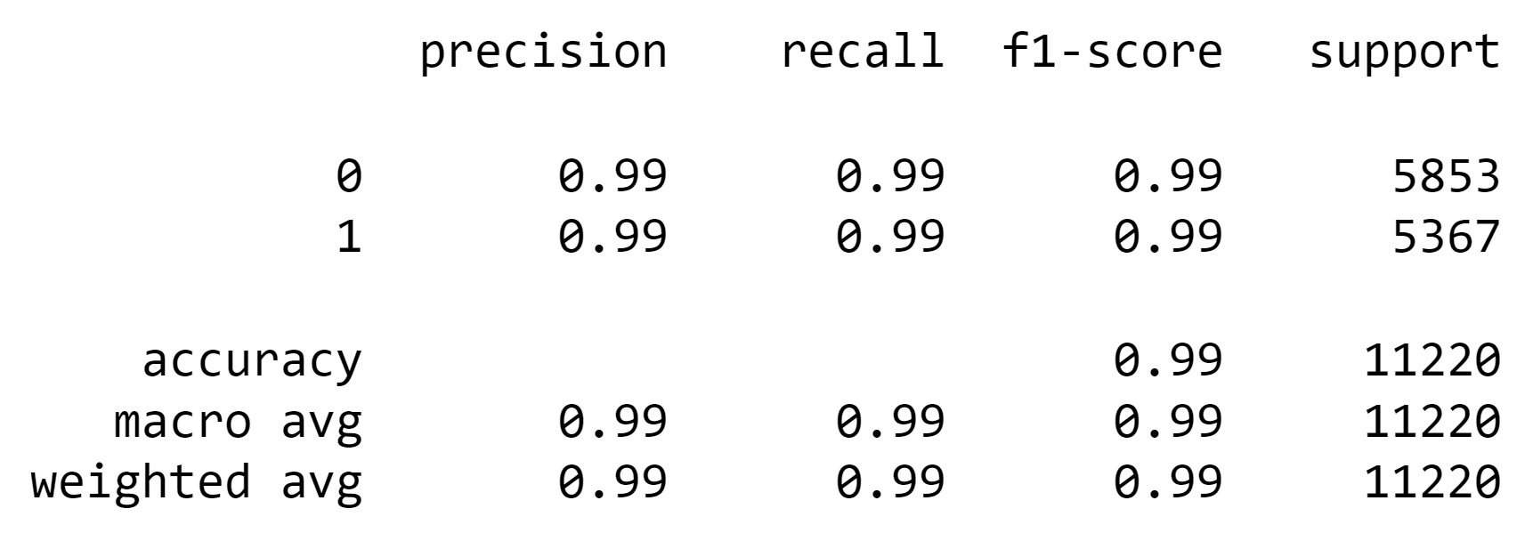

The accuracy of the model is quite high, considering it is about 99%.

**2.Decision Tree classifier**

**Program:**

From sklearn.tree import DecisionTreeClassifier

DT = DecisionTreeClassifier()

DT.fit(xv_train, y_train)

**Output:**

DecisionTreeClassifier()

Pred_dt=DT,predict(xv_test)

DT.score(xv_test, y_test)

**Output:**

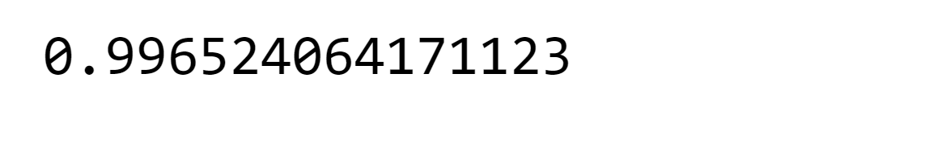

Print(classification_report(y_test, pred_dt))

**Output:**

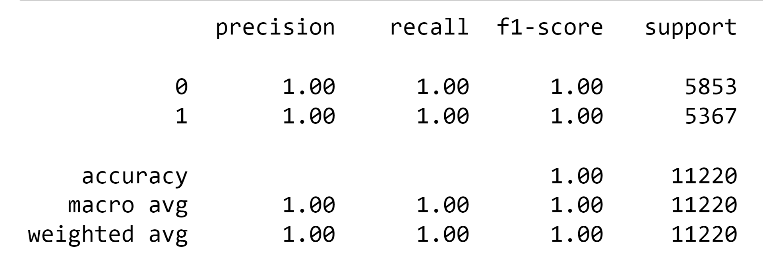

The accuracy Decision Tree Classifier is around 99% which is almost close to perfect.

**3.Gradient Boost classifier:**

**Program:**

From sklearn.ensemble import GradientBoostingClassifier

GBC = GradientBoostingClassifier(random_state=0)

GBC.fit(xv_train, y_train)

**Output:**



Pred_gbc = GBC.predict(xv_test)

GBC.score(xv_test, y_test)

**Output:**

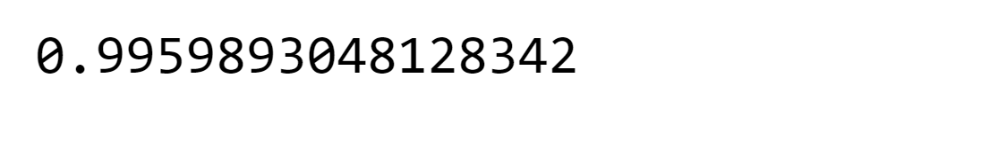

Print(classification_report(y_test, pred_gbc))

**Output:**

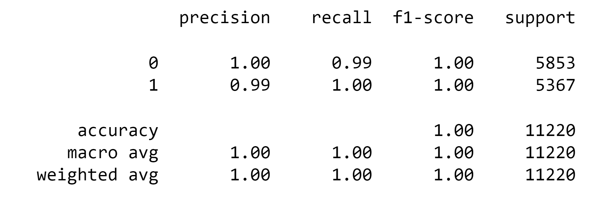

The same is the case with Gradient Boost Classifier.

**4.Random Forest classifier:**

**Program:**

From sklearn.ensemble import RandomForestClassifier

RFC = RandomForestClassifier(random_state=0)

RFC.fit(xv_train, y_train)

**Output:**



Pred_rfc = RFC.predict(xv_test)

RFC.score(xv_test, y_test)

**Output:**

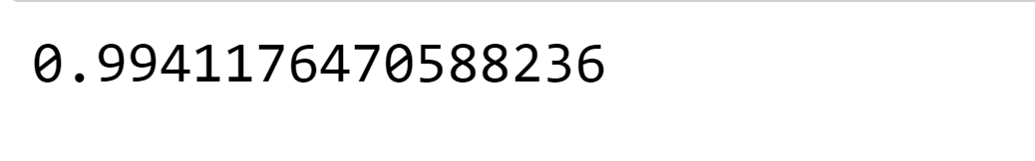

Print(classification_report(y_test, pred_rfc))

**Output:**

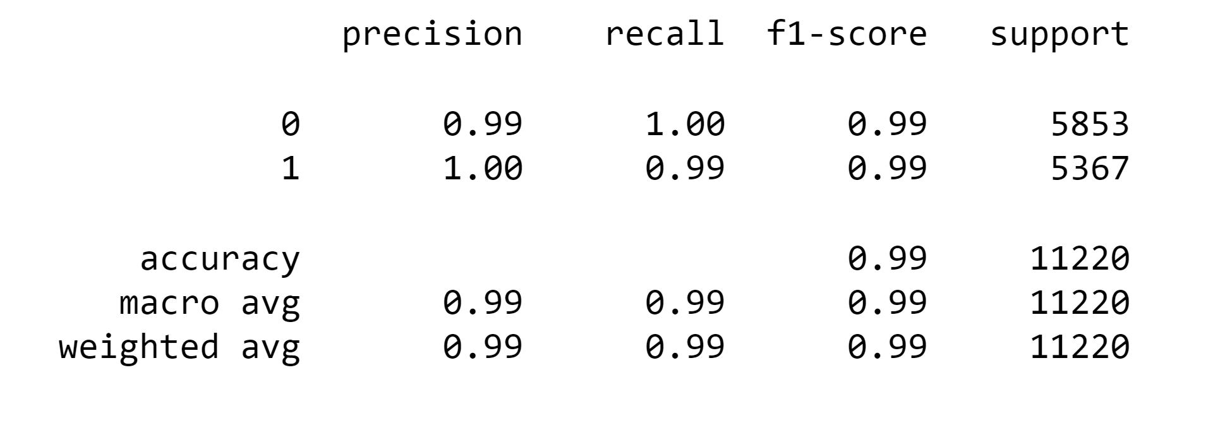

Random Forest Classifiers’ accuracy is also high.

The accuracy of all the machine learning models is almost the same, 99%

**Model Testing**

Here we are going to use all four models to check whether they are capable of detecting fake news. We have to check manually.

def output_lable(n):

    if n == 0:

        return "Fake News"

    elif n == 1:

        return "Not A Fake News"  def manual_testing(news):

    testing_news = {"text":[news]}

    new_def_test = pd.DataFrame(testing_news)

    new_def_test["text"] = new_def_test["text"].apply(wordopt)

    new_x_test = new_def_test["text"]

    new_xv_test = vectorization.transform(new_x_test)

    pred_LR = LR.predict(new_xv_test)

    pred_DT = DT.predict(new_xv_test)

    pred_GBC = GBC.predict(new_xv_test)

    pred_RFC = RFC.predict(new_xv_test)

    return print("\n\nLR Prediction: {} \nDT Prediction: {} \nGBC Prediction: {} \nRFC Prediction: {}".format(output_lable(pred_LR[0]),                                                                                                       output_lable(pred_DT[0]),

                                                                                                              output_lable(pred_GBC[0]),

                                                                                                              output_lable(pred_RFC[0])))

news = str(input())

manual_testing(news)

**output:**

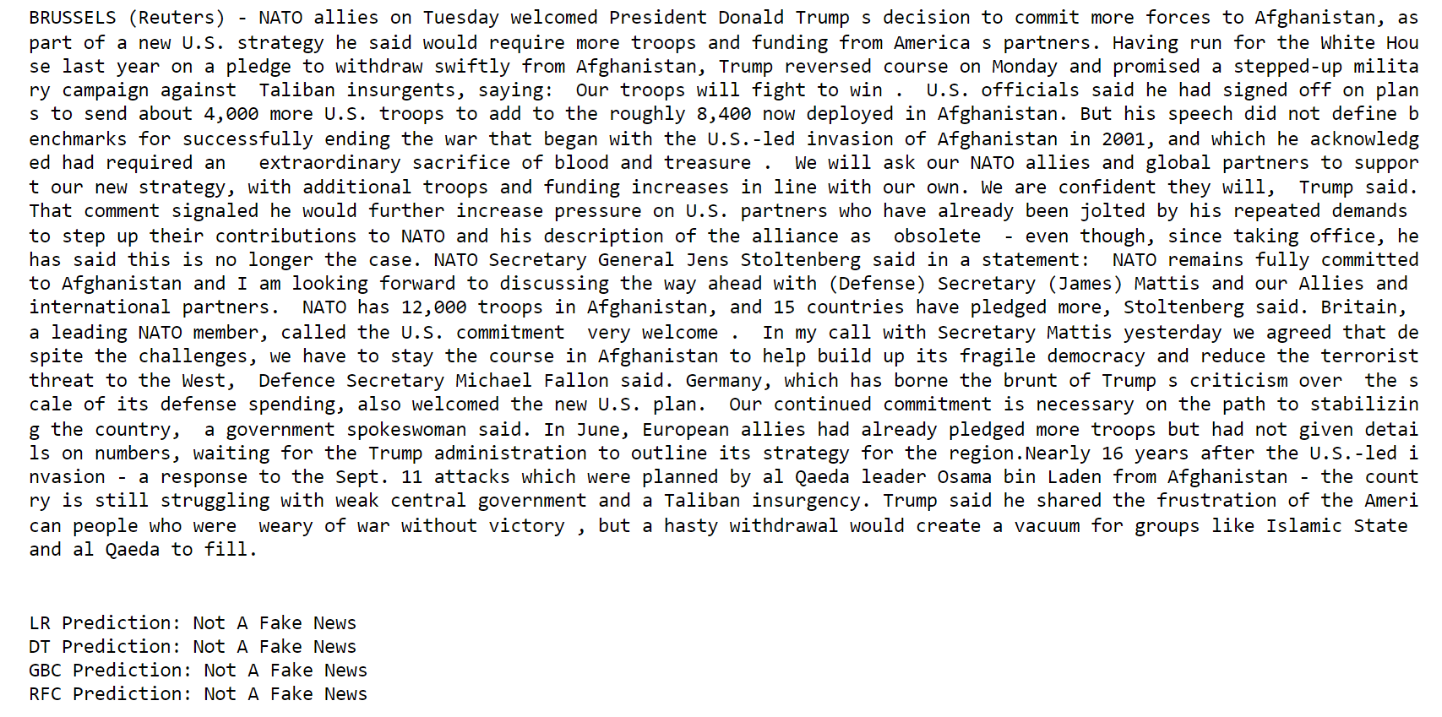

Absolutely right; the prediction is correct.

news = str(input())

manual_testing(news)

**Output:**

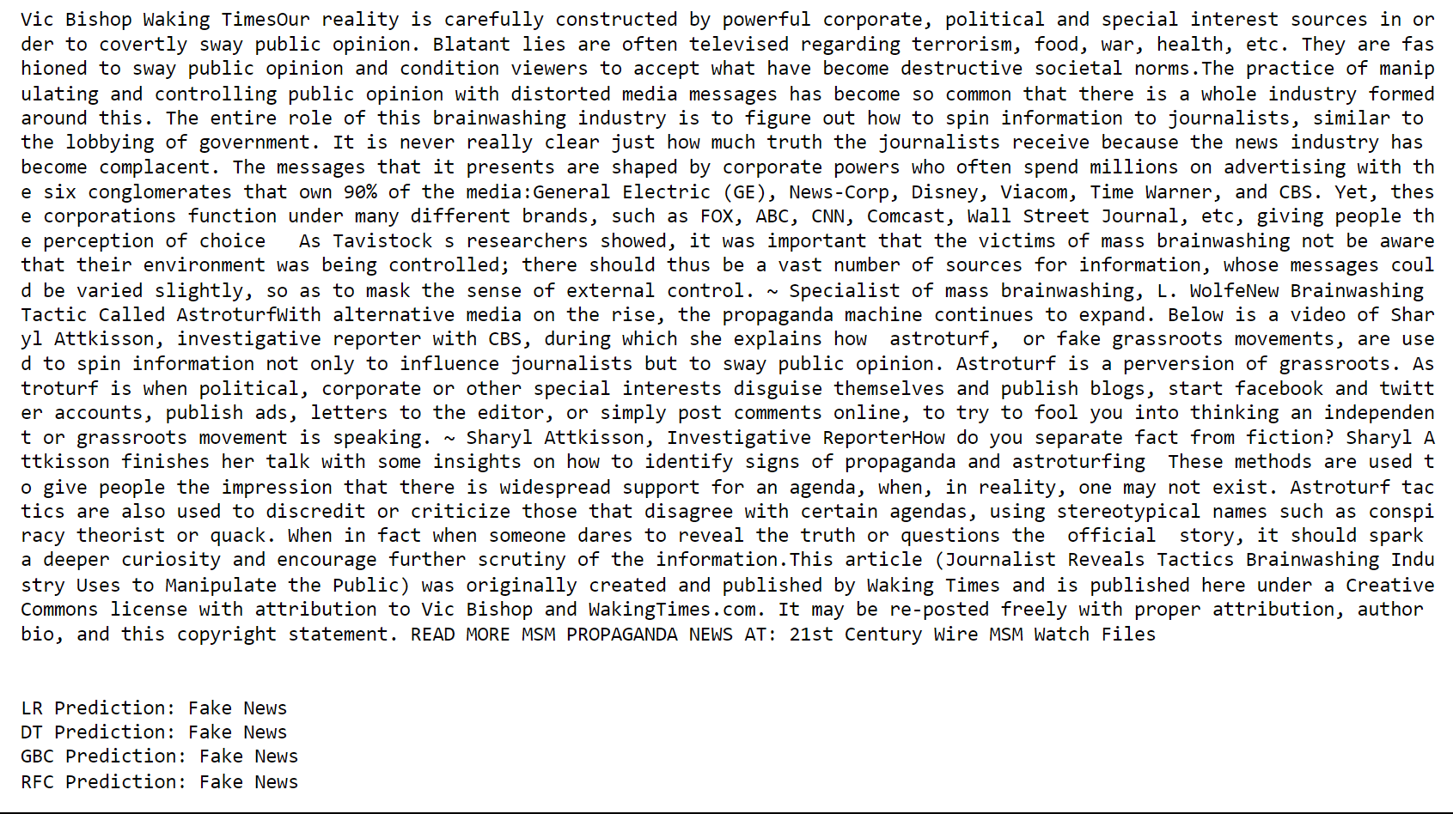

Absolutely right; the prediction is correct.

dataframe_true.head()

news = str(input())

manual_testing(news)

**Output:**

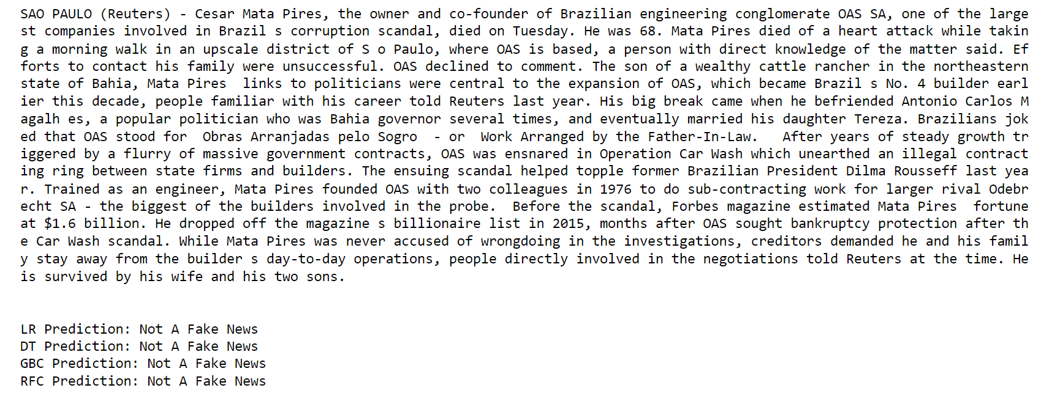

Absolutely right; the prediction is correct.

The model we have made is producing accurate results, considering the accuracy of all the models, which was almost 99%, so we can say machine learning can be used as a tool for detecting fake news.

**Model training, Evaluation, and Prediction**

Now, the dataset is ready to train the model.

For training we will use Logistic Regression and evaluate the prediction accuracy using accuracy_score.

from sklearn.linear_model import LogisticRegression

model = LogisticRegression()

model.fit(x_train, y_train)

# testing the model print(accuracy_score(y_train, model.predict(x_train))) print(accuracy_score(y_test, model.predict(x_test)))

**Output :**

0.993766511324171

0.9893143365983972

Let’s train with Decision Tree Classifier.

from sklearn.tree import DecisionTreeClassifier

model = DecisionTreeClassifier()

model.fit(x_train, y_train)

# testing the model print(accuracy_score(y_train, model.predict(x_train))) print(accuracy_score(y_test, model.predict(x_test)))

**Output :**

0.9999703167205913

0.9951914514692787

The confusion matrix for Decision Tree Classifier can be implemented with the code below.

# Confusion matrix of Results from Decision Tree classification

from sklearn import metrics cm = metrics.confusion_matrix(y_test, model.predict(x_test)) cm_display = metrics.ConfusionMatrixDisplay(confusion_matrix=cm,

display_labels=[False, True]) cm_display.plot()

plt.show()

**Output:**

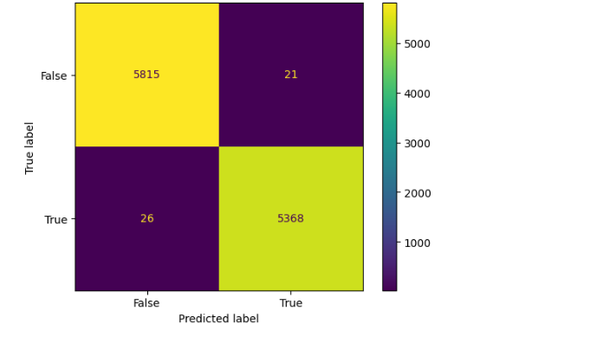

**Conclusion:**

In conclusion, the project on fake news detection using Natural Language Processing (NLP) represents a significant step towards addressing the growing challenge of misinformation and disinformation in the digital age. Through this endeavor, we've explored a range of NLP techniques and methodologies that enable the automatic identification of fake news, aiding in the preservation of trustworthy information sources.

This project has demonstrated the potential of NLP in parsing and analyzing text data, uncovering deceptive linguistic patterns, and employing machine learning models to classify news articles accurately. While progress has been made, it's essential to acknowledge that fake news detection remains a dynamic field, and ongoing research and development are required to keep pace with evolving tactics employed by purveyors of misinformation.

Ultimately, the use of NLP in fake news detection contributes to the broader efforts to promote information integrity, critical thinking, and media literacy. As technology and society continue to evolve, this project stands as a valuable contribution to the ongoing battle against fake news and the safeguarding of accurate and reliable information for the benefit of all.